Video Quick Guide

So you’re ready to shoot some videos – that’s great! Here are some quick tips to make sure it’s awesome:

- Juice: Make sure your device is charged up and you have a charger on hand and/or you have a spare battery before starting.

- Take plenty of video: Don’t be afraid to shoot and shoot and shoot. It might take you a couple tries to get the perfect shot and there’s no such thing as having too much b-roll (or alternative material); b-roll helps to add depth to a story and help with cutaways.

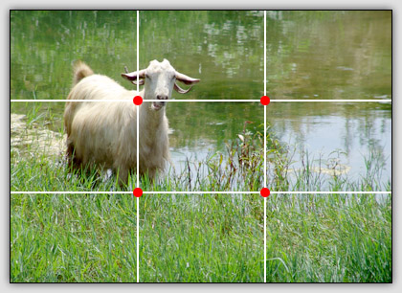
- Rule of thirds: When filming a subject, it’s not appealing to have subjects smack in the middle. Imagine your frame is broken up into three parts and frame subjects a bit off center (see right image). Always have your subject looking into the frame instead of outside (left subject looking right, etc.); this also helps to anticipate the subjects’ movements and give the shot some depth

- Steady & hold: Try to hold your shots as steady as possible (a tripod works best for this – highly recommend - and you can get one fairly cheap these days; if you’re using an iPhone, get an adapter to be able to put it on the tripod, like a Joby Grip). Also hold it for about 5 seconds longer than you think you should. This will help later when editing. If you can’t put down the cash for a tripod or you find yourself shooting unexpectedly, think of your body as a tripod. Don’t hold your arms out, causing instability, but keep your elbows in to keep the iPhone steady.

- Light: If you don’t have any lights, natural light works great, so get outside, or on a very sunny day, use shades as a cheap diffuser. To avoid harsh shadows, shoot in the shade or even better, on an overcast day. If you do, a three-light set up is great: one on each side of your subject, and a “keylight” behind them, like this:
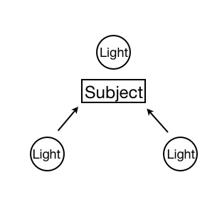

- Sound: You’ll want to get a microphone, which should be placed above your subjects head if possible. You can also get some lav mics to pin to your subject. Either way, put headphones on to make sure you can hear your subject (having headphones plugged into your camera can help you hear what you’re capturing). Recording about 30 seconds of the sound around you when you’re finished with your subject will also help you have the best audio in post to layer it on your sequence.

- Keep it simple: Straight static shots are best. Avoid using too many effects (slow-mo, etc) or pans (occasional is fine, but don’t over do it). You definitely don’t want to zoom if you’re using an iPhone – it diminishes the quality and you get a pixilated image – so stick to physically moving the phone closer.

